OPERATING SYSTEM

IT - 204

LAB FILE

SUBMITTED
BY: -

RITWIJ KASHYAP

2K21/IT/147

SUBMITTED TO: -

Dr. Ritu Agarwal


DEPARTMENT OF INFORMATION TECHNOLOGY DELHI TECHNOLOGICAL UNIVERSITY (FORMERLY DELHI COLLEGE OF ENGINEERING)

BAWANA ROAD, DELHI-110042
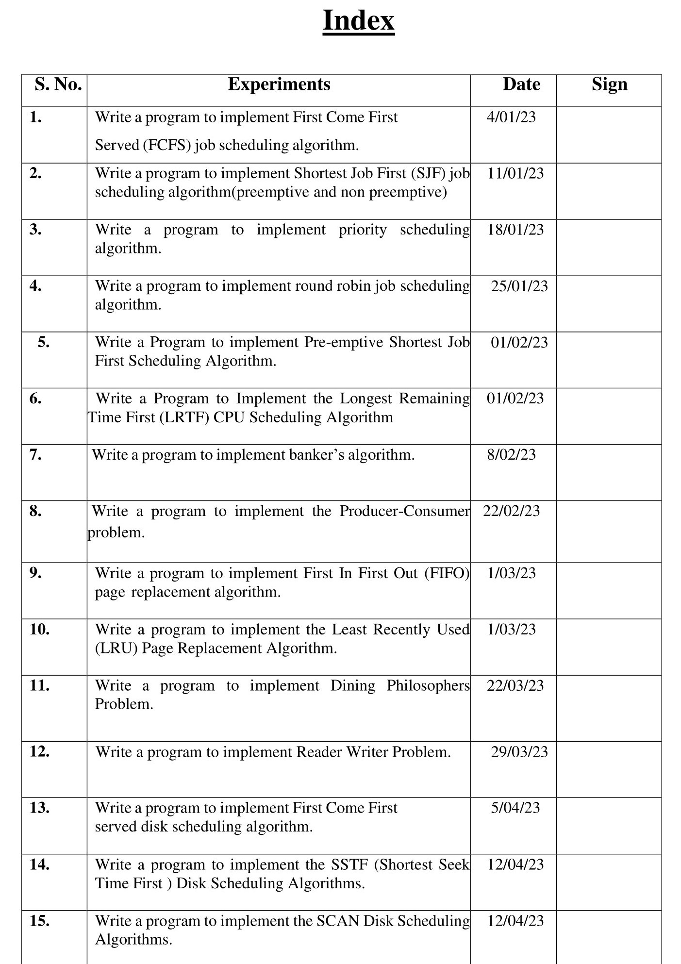
EXPERIMENT - 1

Aim: WAP to implement First Come First Serve (FCFS) CPU scheduling algorithm.

Description: First come first serve (FCFS) scheduling algorithm simply schedules the jobs according to their arrival time. The job which comes first in the ready queue will get the CPU first. The lesser the arrival time of the job, the sooner will the job get the CPU. FCFS scheduling may cause the problem of starvation if the burst time of the first process is the longest among all the jobs.

Pseudocode:

1- Input the processes along with their burst time (bt).

2- Find waiting time (wt) for all processes.

3- As first process that comes need not to wait so waiting time for process 1 will be 0 i.e. wt[0] = 0.
4- Find waiting time for all other processes i.e. for process i ->
wt[i] = bt[i-1] + wt[i-1] .

5- Find turnaround time = waiting_time + burst_time for all processes.
6- Find average waiting time =

total_waiting_time / no_of_processes.

7- Similarly, find average turnaround time =

total_turn_around_time / no_of_processes.

Implementation:

#include <iostream>
using namespace std;
void findWaitingTime(int processes[], int n, int bt[], int wt[])
{
wt[0] = 0;
for (int i = 1; i < n; i++)
wt[i] = bt[i - 1] + wt[i - 1];
}

void findTurnAroundTime(int processes[], int n, int bt[], int wt[], int tat[])
{

for (int i = 0; i < n; i++)
tat[i] = bt[i] + wt[i];
}

void findavgTime(int processes[], int n, int bt[])
{
int wt[n], tat[n], total_wt = 0, total_tat = 0;
findWaitingTime(processes, n, bt, wt);
findTurnAroundTime(processes, n, bt, wt, tat);
cout << "Processes "
<< " Burst time "

<< " Waiting time "
<< " Turn around time\n";

for (int i = 0; i < n; i++)
{
total_wt = total_wt + wt[i];
total_tat = total_tat + tat[i];
cout << " " << i + 1 << "\t\t" << bt[i] << "\t "
<< wt[i] << "\t\t " << tat[i] << endl;
}
cout << "Average waiting time = "
<< (float)total_wt / (float)n;
cout << "\nAverage turn around time = "
<< (float)total_tat / (float)n;
}
int main()
{
int n;
cout << "Enter no. of processes" << endl;
cin >> n;
int processes[n];
int burst_time[n];
for (int i = 0; i < n; i++)
{
cout << "Enter process id and burst time" << endl;
cin >> processes[i];
cin >> burst_time[i];
}
findavgTime(processes, n, burst_time);
}

Input :

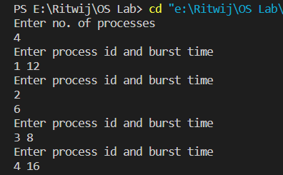

Output:

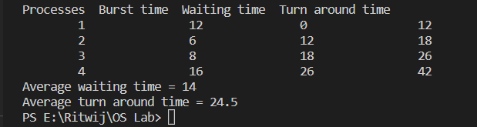

Conclusion :

From this practical, we learned about First Come and First Serve algorithm and how to implement and find waiting time using the given burst time for the case where arrival time is considered the same.
EXPERIMENT - 2

AIM: Write a Program to implement the Shortest Job First (SJF) CPU Scheduling Algorithm.

Description: The Shortest Job First (SJF) CPU scheduling algorithm is a non-pre-emptive scheduling algorithm that selects the process with the shortest burst time from the ready queue for execution. The idea behind this algorithm is to minimize the average waiting time of processes by giving priority to shorter jobs.

Pseudocode:

- Firstly, Start process.

- Declare array size i.e. A[10].

- Take number of elements to be inserted.

- Select process which have shortest burst time Among all process will execute first.

- If process have same burst time length then FCFS ( First come First Serve ) scheduling algorithm used.
- Make average waiting time length of next process.

- Start with first process, selection as above and other processes are to be in queue.

- Calculates Burst total number of time.

- Display the Related values.

- Now Close / Stop process.

Implementation:

#include <iostream>

using namespace std;
int main()
{

int A[100][4];

int i, j, n, total = 0, index, temp;
float avg_wt, avg_tat;
cout << "Enter number of processes: ";
cin >> n;
cout << "Enter Burst Time:\n";

for (i = 0; i < n; i++)
{

cout << "P" << i + 1 << ": ";
cin >> A[i][1];
A[i][0] = i + 1;
}
for (i = 0; i < n; i++)
{
index = i;
for (j = i + 1; j < n; j++)

if (A[j][1] < A[index][1])

index = j;
temp = A[i][1];
A[i][1] = A[index][1];
A[index][1] = temp;

temp = A[i][0];

A[i][0] = A[index][0];
A[index][0] = temp;
}
A[0][2] = 0;

for (i = 1; i < n; i++)
{

A[i][2] = 0;
for (j = 0; j < i; j++)
A[i][2] += A[j][1];
total += A[i][2];
}
avg_wt = (float)total / n;
total = 0;
cout << "P BT WT TAT\n";

for (i = 0; i < n; i++)
{

A[i][3] = A[i][1] + A[i][2];
total += A[i][3];
cout << "P" << A[i][0] << " " << A[i][1] << " " << A[i][2] << " " << A[i][3] << endl;
}
avg_tat = (float)total / n;
cout << "Average Waiting Time= " << avg_wt;
cout << "\nAverage Turnaround Time= " << avg_tat;
}

Input:

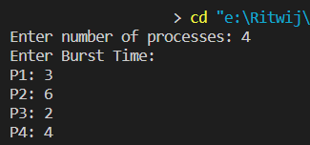

Output:

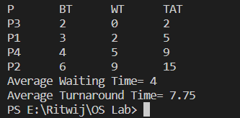

Conclusion:

From this practical, we learned about Shortest Job First (SJF) CPU Scheduling Algorithm and how to Implement it and find waiting time using the given burst time for the case where arrival time is considered the same.

EXPERIMENT - 3

Aim: WAP to implement Shortest Job First with remaining time (pre-emptive)

Description: In Shortest Remaining Time First CPU scheduling algorithm, the process with smallest amount of remaining time until completion is selected to perform frst. This scheduling algorithm can be pre-emptive or non-pre-emptive.

Pseudocode:

- Traverse until all process gets completely executed.

  - Find process with minimum remaining time at every single time lap.

  - Reduce its time by 1.

  - Check if its remaining time becomes 0

  - Increment the counter of process completion.

  - Completion time of current process = current_time + 1;

  - Calculate waiting time for each completed process.

    - wt[i]= Completion time – arrival_time-burst_time

  - Increment time lap by one.

- Find turnaround time (waiting_time + burst_time).

Implementation:

#include <bits/stdc++.h>

using namespace std;

struct Process
{

int pid;
int bt;
int art;
};
void findWaitingTime(Process proc[], int n,
int wt[])
{
int rt[n];
for (int i = 0; i < n; i++)
rt[i] = proc[i].bt;

int complete = 0, t = 0, minm = INT_MAX;

int shortest = 0, finish_time;
bool check = false;
while (complete != n)
{
for (int j = 0; j < n; j++)
{
if ((proc[j].art <= t) &&
(rt[j] < minm) && rt[j] > 0)
{
minm = rt[j];
shortest = j;
check = true;
}
}

if (check == false)
{

t++;
continue;
}
minm = rt[shortest];
if (minm == 0)
minm = INT_MAX;
if (rt[shortest] == 0)
{
check = false;
finish_time = t + 1;
proc[shortest].bt - proc[shortest].art;

if (wt[shortest] < 0)

wt[shortest] = 0;
}
}
}
void findTurnAroundTime(Process proc[], int n,

int wt[], int tat[])
{
for (int i = 0; i < n; i++)
tat[i] = proc[i].bt + wt[i];
}
void findavgTime(Process proc[], int n)
{
int wt[n], tat[n], total_wt = 0, total_tat = 0;

findWaitingTime(proc, n, wt);

cout << " P\t\t"
<< "BT\t\t"
<< "WT\t\t"
<< "TAT\t\t\n";

for (int i = 0; i < n; i++)
{
total_wt = total_wt + wt[i];
total_tat = total_tat + tat[i];
cout << " " << proc[i].pid << "\t\t"
<< proc[i].bt << "\t\t " << wt[i]
<< "\t\t " << tat[i] << endl;
}

cout << "\nAverage waiting time = " << (float)total_wt / (float)n;
cout << "\nAverage turn around time = " << (float)total_tat / (float)n;
}
int main()
{
int n;
cout << "Enter number of processes" << endl;
cin >> n;
Process proc[n];

for (int i = 0; i < n; i++)
{

cout << "Enter Pid, burst time and arrival time" << endl;
cin >> proc[i].pid;
cin >> proc[i].bt;
cin >> proc[i].art;
}

findavgTime(proc, n);

return 0;
}

Input :
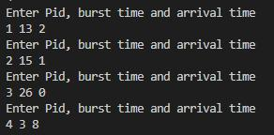

Output:
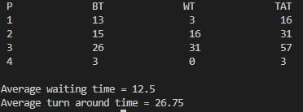

Conclusion:

From this practical, we learned about Shortest Remaining Time First Algorithm with pre-emptive operation and how to implement and find waiting time using the given burst time and arrival Time.
EXPERIMENT - 4

AIM: Write a program to implement the Priority CPU Scheduling Algorithm.

Description: Priority CPU Scheduling Algorithm is a non-pre-emptive scheduling algorithm in which the process with the highest priority is selected for execution. Each process is assigned a priority, and the scheduler selects the process with the highest priority to run next. Priority can be based on various factors, such as the amount of resources the process needs, the time sensitivity of the process, or the importance of the process. The priority can be assigned either internally by the operating system or externally by the user. In Priority CPU Scheduling Algorithm, if two or more processes have the same priority, the algorithm follows a First Come First Serve (FCFS) order to decide which process should be executed first.

Pseudocode:

1- First input the processes with their burst time

and priority.

2- Sort the processes, burst time and priority

according to the priority.

3- Now simply apply FCFS algorithm.

Implementation:

#include<bits/stdc++.h>

using namespace std;

struct Process
{
int pid;
int bt;
int priority;
};

bool comparison(Process a, Process b)
{
return (a.priority > b.priority);
}

void findWaitingTime(Process proc[], int n, int wt[])
{
wt[0] = 0;
for (int i = 1; i < n ; i++ )
wt[i] = proc[i-1].bt + wt[i-1] ;
}

void findTurnAroundTime(Process proc[], int n,
int wt[], int tat[])
{
for (int i = 0; i < n ; i++)
tat[i] = proc[i].bt + wt[i];
}

void findavgTime(Process proc[], int n)
{
int wt[n], tat[n], total_wt = 0, total_tat = 0;

findWaitingTime(proc, n, wt);

findTurnAroundTime(proc, n, wt, tat);

cout << "\nProcesses "<< " Burst time "
<< " Waiting time " << " Turnaround time\n";

for (int i=0; i<n; i++)
{
total_wt = total_wt + wt[i];
total_tat = total_tat + tat[i];
cout << " " << proc[i].pid << "\t\t"
<< proc[i].bt << "\t " << wt[i]
<< "\t\t " << tat[i] <<endl;
}

cout << "\nAverage waiting time = "

<< (float)total_wt / (float)n;
cout << "\nAverage turnaround time = "
<< (float)total_tat / (float)n;
}

void priorityScheduling(Process proc[], int n)

{
sort(proc, proc + n, comparison);

cout<< "Order in which processes gets executed \n"; for (int i = 0 ; i < n; i++)

cout << proc[i].pid <<" " ;

findavgTime(proc, n);

}
int main()
{
int n;
cout<<"Enter number of processes"<<endl; cin>>n;
Process proc[n];

for(int i=0; i<n; i++){

cout<<"Enter Pid, burst time and priority"<<endl;
cin>>proc[i].pid;
cin>>proc[i].bt;
cin>>proc[i].priority;
}

priorityScheduling(proc, n);

return 0;
}

Input :

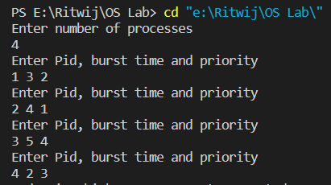

Output :

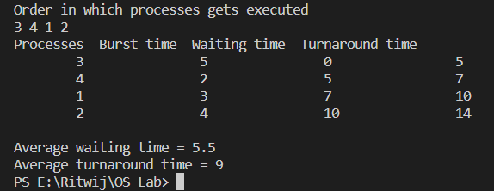

Conclusion :

From this practical, we learned about Priority CPU Scheduling Algorithm and how to Implement it and find waiting time using the given burst time.
EXPERIMENT - 5

AIM : Write a program to implement the Priority CPU Scheduling Algorithm(preemptively).

Description:

The Priority CPU Scheduling Algorithm (preemptive) is a scheduling algorithm used in operating systems to determine the order in which processes are executed by the CPU. In this algorithm, each process is assigned a priority, which determines the order in which it is executed. Processes with higher priority are executed before processes with lower priority. In preemptive priority scheduling, if a higher-priority process arrives during the execution of a lower-priority process, the lower-priority process is preempted and the higher-priority process is executed instead. The preempted process is added back to the ready queue, and the algorithm continues selecting processes based on their priority.

Pseudocode:

- Initialize the current time to 0, an empty ready queue, and a completed queue.

- While there are still uncompleted processes:

a. Add all processes that have arrived to the ready queue.

    - Sort the ready queue in non-decreasing order by priority.

    - Select the process with the highest priority from the ready queue.

    - Run the process for one time unit.

e. If the process has completed, set its completion time and waiting time, and move it to the completed queue.
f. If the process has not completed, add it back to the ready queue.

g. Increment the current time by one time unit.

● Output the completion time and waiting time for each process in the completed queue

Implementation:

#include <iostream>

#include <algorithm>
#include <iomanip>
#include <string.h>
using namespace std;

struct process
{

int pid;
int arrival_time;
int burst_time;

int priority;

int start_time;
int completion_time;
int turnaround_time;
int waiting_time;
int response_time;
};

int main()
{

int n;

struct process p[100];
float avg_turnaround_time;
float avg_waiting_time;
float avg_response_time;
float cpu_utilisation;
int total_turnaround_time = 0;
int total_waiting_time = 0;
int total_response_time = 0;
int total_idle_time = 0;
float throughput;
int burst_remaining[100];
int is_completed[100];
memset(is_completed, 0, sizeof(is_completed));

cout << setprecision(2) << fixed;

cout << "Enter the number of processes: ";

cin >> n;

for (int i = 0; i < n; i++)
{

cout << "Enter arrival time of process " << i + 1 << ": ";
cin >> p[i].arrival_time;
cout << "Enter burst time of process " << i + 1 << ": ";
cin >> p[i].burst_time;
cout << "Enter priority of the process " << i + 1 << ": ";
cin >> p[i].priority;
p[i].pid = i + 1;
burst_remaining[i] = p[i].burst_time;
cout << endl;
}

int current_time = 0;

int completed = 0;
int prev = 0;

while (completed != n)
{

int idx = -1;
int mx = -1;
for (int i = 0; i < n; i++)
{
if (p[i].arrival_time <= current_time && is_completed[i] == 0)
{

if (p[i].priority > mx)
{

mx = p[i].priority;
idx = i;
}
if (p[i].priority == mx)
{
if (p[i].arrival_time < p[idx].arrival_time)
{
mx = p[i].priority;
idx = i;
}
}
}
}

if (idx != -1)
{

if (burst_remaining[idx] == p[idx].burst_time)
{
p[idx].start_time = current_time;
total_idle_time += p[idx].start_time - prev;
}
burst_remaining[idx] -= 1;
current_time++;
prev = current_time;

if (burst_remaining[idx] == 0)
{

p[idx].completion_time = current_time;
p[idx].turnaround_time = p[idx].completion_time - p[idx].arrival_time;
p[idx].waiting_time = p[idx].turnaround_time - p[idx].burst_time;
p[idx].response_time = p[idx].start_time - p[idx].arrival_time;

total_turnaround_time += p[idx].turnaround_time;
total_waiting_time += p[idx].waiting_time;
total_response_time += p[idx].response_time;

is_completed[idx] = 1;

completed++;
}
}
else
{
current_time++;
}
}

int min_arrival_time = 10000000;

int max_completion_time = -1;
for (int i = 0; i < n; i++)
{
min_arrival_time = min(min_arrival_time, p[i].arrival_time);
max_completion_time = max(max_completion_time, p[i].completion_time);
}

avg_turnaround_time = (float)total_turnaround_time / n;
avg_waiting_time = (float)total_waiting_time / n;
avg_response_time = (float)total_response_time / n;

cpu_utilisation = ((max_completion_time - total_idle_time) / (float)max_completion_time) * 100;

throughput = float(n) / (max_completion_time - min_arrival_time);

cout << endl
<< endl;

cout << "#P\t"
<< "AT\t"
<< "BT\t"
<< "PRI\t"
<< "ST\t"
<< "CT\t"
<< "TAT\t"
<< "WT\t"
<< "RT\t"
<< "\n"
<< endl;

for (int i = 0; i < n; i++)
{

cout << p[i].pid << "\t" << p[i].arrival_time << "\t" << p[i].burst_time << "\t" << p[i].priority << "\t" << p[i].start_time << "\t" << p[i].completion_time << "\t" << p[i].turnaround_time << "\t" << p[i].waiting_time << "\t" << p[i].response_time << "\t"
<< "\n"
<< endl;
}
cout << "Average Turnaround Time = " << avg_turnaround_time << endl;
cout << "Average Waiting Time = " << avg_waiting_time << endl;
cout << "Average Response Time = " << avg_response_time << endl;
cout << "CPU Utilization = " << cpu_utilisation << "%" << endl;
cout << "Throughput = " << throughput << " process/unit time" << endl;
}

Input:

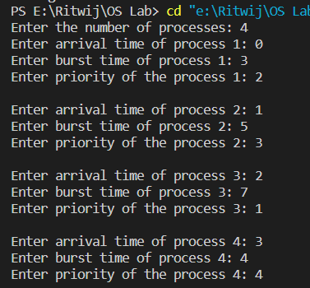

Output:

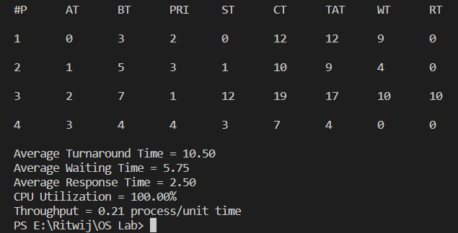

Conclusion:

From this practical, we learned about Priority CPU Scheduling Algorithm(preemptively) and how to Implement it and find waiting time using the given burst time.
EXPERIMENT - 6

AIM: Write a program to implement the Round Robin Scheduling Algorithm.

Description:

A round-robin scheduling algorithm is used to schedule the process fairly for each job a time slot or quantum and the interrupting the job if it is not completed by then the job come after the other job which is arrived in the quantum time that makes these scheduling fairly.

Pseudocode:

- Declare arrival[], burst[], wait[], turn[] arrays and initialize them. Also declare a timer variable and initialize it to zero. To sustain the original burst array create another array (temp_burst[]) and copy all the values of burst array in it.
- To keep a check we create another array of bool type which keeps the record of whether a process is completed or not. we also need to maintain a queue array which contains the process indices (initially the array is filled with 0).
- Now we increment the timer variable until the first process arrives and when it does, we add the process index to the queue array
- Now we execute the first process until the time quanta and during that time quanta, we check whether any other process has arrived or not and if it has then we add the index in the queue (by calling the fxn. queueUpdation()).
- Now, after doing the above steps if a process has finished, we store its exit time and execute the next process in the queue array. Else, we move the currently executed process at the end of the queue (by calling another fxn. queueMaintainence()) when the time slice expires.
- The above steps are then repeated until all the processes have been completely executed. If a scenario arises where there are some processes left but they have not arrived yet, then we shall wait and the CPU will remain idle during this interval.

Implementation:

#include <iostream>

using namespace std;

void queueUpdation(int queue[], int timer, int arrival[], int n, int maxProccessIndex)
{
int zeroIndex;

for (int i = 0; i < n; i++)
{
if (queue[i] == 0)
{
zeroIndex = i;
break;
}
}

queue[zeroIndex] = maxProccessIndex + 1;
}

void queueMaintainence(int queue[], int n)
{
for (int i = 0; (i < n - 1) && (queue[i + 1] != 0); i++)
{

int temp = queue[i];
queue[i] = queue[i + 1];
queue[i + 1] = temp;
}
}

void checkNewArrival(int timer, int arrival[], int n, int maxProccessIndex, int queue[])
{
if (timer <= arrival[n - 1])
{

bool newArrival = false;
for (int j = (maxProccessIndex + 1); j < n; j++)
{
if (arrival[j] <= timer)
{
if (maxProccessIndex < j)
{
maxProccessIndex = j;
newArrival = true;
}
}
}
// adds the incoming process to the ready queue
//(if any arrives)
if (newArrival)
queueUpdation(queue, timer, arrival, n, maxProccessIndex);
}
}

// Driver Code

int main()
{
int n, tq, timer = 0, maxProccessIndex = 0;
float avgWait = 0, avgTT = 0;
cout << "\nEnter the time quanta : ";
cin >> tq;
cout << "\nEnter the number of processes : ";
cin >> n;
int arrival[n], burst[n], wait[n], turn[n], queue[n], temp_burst[n];
bool complete[n];

cout << "\nEnter the arrival time of the processes : ";
for (int i = 0; i < n; i++)

cin >> arrival[i];

cout << "\nEnter the burst time of the processes : ";
for (int i = 0; i < n; i++)
{

cin >> burst[i];
temp_burst[i] = burst[i];
}

for (int i = 0; i < n; i++)
{ // Initializing the queue and complete array

complete[i] = false;

queue[i] = 0;
}
while (timer < arrival[0]) // Incrementing Timer until the first process arrives
timer++;
queue[0] = 1;

while (true)
{

bool flag = true;
for (int i = 0; i < n; i++)
{
if (temp_burst[i] != 0)
{
flag = false;
break;
}
}
if (flag)
break;

for (int i = 0; (i < n) && (queue[i] != 0); i++)
{

int ctr = 0;
while ((ctr < tq) && (temp_burst[queue[0] - 1] > 0))
{
temp_burst[queue[0] - 1] -= 1;
timer += 1;
ctr++;

// Checking and Updating the ready queue until all the processes arrive
checkNewArrival(timer, arrival, n, maxProccessIndex, queue);
}
// If a process is completed then store its exit time //and mark it as completed
if ((temp_burst[queue[0] - 1] == 0) && (complete[queue[0] - 1] == false))
{ // turn array currently stores the completion time
turn[queue[0]-1] = timer;
complete[queue[0] - 1] = true;
}

// checks whether or not CPU is idle

bool idle = true;
if (queue[n - 1] == 0)
{
for (int i = 0; i < n && queue[i] != 0; i++)
{
if (complete[queue[i] - 1] == false)
{
idle = false;
}
}
}
else
idle = false;

if (idle)
{

timer++;
checkNewArrival(timer, arrival, n, maxProccessIndex, queue);
}

// Maintaining the entries of processes

// after each premption in the ready Queue
queueMaintainence(queue, n);
}
}

for (int i = 0; i < n; i++)
{

turn[i] = turn[i] - arrival[i];
wait[i] = turn[i] - burst[i];
}

cout << "\nProgram No.\tArrival Time\tBurst Time\tWait Time\tTurnAround Time" << endl;

for (int i = 0; i < n; i++)
{
cout << i + 1 << "\t\t" << arrival[i] << "\t\t"
<< burst[i] << "\t\t" << wait[i] << "\t\t" << turn[i] << endl;
}
for (int i = 0; i < n; i++)
{
avgWait += wait[i];
avgTT += turn[i];
}
cout << "\nAverage wait time : " << (avgWait / n)
<< "\nAverage Turn Around Time : " << (avgTT / n);

return 0;
}
Input:

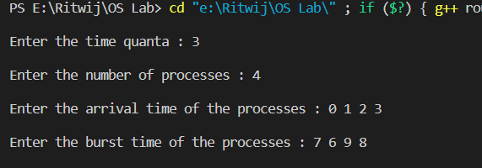

Output:

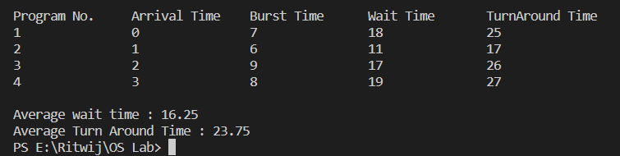

Conclusion:

From this practical, we learned about Round Robin CPU Scheduling Algorithm and how to Implement it and find waiting time using the given burst time

EXPERIMENT-7

Aim:
WAP to implement longest remaining time first

Theory:
Longest Remaining Time First (LRTF) is a pre-emptive version of Longest Job First (LJF) scheduling algorithm. In this scheduling algorithm, we find the process with the maximum remaining time and then process it, i.e. check for the maximum remaining time after some interval of time(say 1 unit each) to check if another process having more Burst Time arrived up to that time. Among all the processes waiting in a waiting queue, CPU is always assigned to the process having largest burst time. If two processes have the same burst time then the tie is broken using FCFS i.e. the process that arrived first is processed first. LJF CPU Scheduling can be of both pre-emptive and non-pre-emptive type.

Algorithm:
• First, sort the processes in increasing order of their Arrival Time.
• Choose the process having least arrival time but with most Burst Time.
• Then process it for 1 unit. Check if any other process arrives upto that time of execution or not.
• Repeat the above both steps until execute all the processes.

Code:

#include <iostream>
#include <algorithm>
using namespace std;
struct node
{
char pname;
int btime;
int atime;
int restime = 0;
int ctime = 0;
int wtime = 0;
} a[1000], b[1000], c[1000];
void insert(int n)
{
int i;
for (i = 0; i < n; i++)
{
cin >> a[i].pname;
cin >> a[i].atime;
cin >> a[i].btime;
a[i].wtime = -a[i].atime + 1;
}
}
bool btimeSort(node a, node b)
{
return a.btime < b.btime;
}
bool btimeOppSort(node a, node b)
{
if (a.btime != b.btime)
return a.btime > b.btime;
return a.atime < b.atime;
}
bool atimeSort(node a, node b)
{
return a.atime < b.atime;
}
int k = 0, f = 0, r = 0;
void disp(int nop, int qt)
{
int n = nop, q;
sort(a, a + n, atimeSort);
int ttime = 0, i;
int j, tArray[n];
int alltime = 0;
bool moveLast = false;
for (i = 0; i < n; i++)
{
alltime += a[i].btime;
}
alltime += a[0].atime;
for (i = 0; ttime <= alltime;)
{
j = i;
while (a[j].atime <= ttime && j != n)
{

b[r] = a[j];
j++;
r++;
}
if (r == f)
{
c[k].pname = 'i';
c[k].btime = a[j].atime - ttime;
c[k].atime = ttime;
ttime += c[k].btime;
k++;
continue;
}
i = j;
if (moveLast == true)
{
sort(b + f, b + r, btimeOppSort);
}
j = f;
if (b[j].btime > qt)
{
c[k] = b[j];
c[k].btime = qt;
k++;
b[j].btime = b[j].btime - qt;
ttime += qt;
moveLast = true;
for (q = 0; q < n; q++)
{
if (b[j].pname != a[q].pname)
{
a[q].wtime += qt;
}
}
}
else
{
c[k] = b[j];
k++;
f++;
ttime += b[j].btime;
moveLast = false;
for (q = 0; q < n; q++)
{
if (b[j].pname != a[q].pname)
{
a[q].wtime += b[j].btime;
}
}
}
if (f == r && i >= n)
break;
}
tArray[i] = ttime;
ttime += a[i].btime;
for (i = 0; i < k - 1; i++)
{
if (c[i].pname == c[i + 1].pname)
{
c[i].btime += c[i + 1].btime;
for (j = i + 1; j < k - 1; j++)
c[j] = c[j + 1];
k--;
i--;
}
}

int rtime = 0;
for (j = 0; j < n; j++)
{
rtime = 0;
for (i = 0; i < k; i++)
{
if (c[i].pname == a[j].pname)
{
a[j].restime = rtime;
break;
}
rtime += c[i].btime;
}
}
float averageWaitingTime = 0;
float averageResponseTime = 0;
float averageTAT = 0;

cout << "\nGantt Chart\n";

rtime = 0;
for (i = 0; i < k; i++)
{
if (i != k)
cout << "| " << 'P' << c[i].pname << " ";
rtime += c[i].btime;
for (j = 0; j < n; j++)
{
if (a[j].pname == c[i].pname)
a[j].ctime = rtime;
}
}
cout << "\n";
rtime = 0;
for (i = 0; i < k + 1; i++)
{
cout << rtime << "\t";
tArray[i] = rtime;
rtime += c[i].btime;
}
cout << "\n";
cout << "\n";
cout << "P.Name AT\tBT\tCT\tTAT\tWT\tRT\n";
for (i = 0; i < nop && a[i].pname != 'i'; i++)
{
if (a[i].pname == '\0')
break;
cout << 'P' << a[i].pname << "\t";
cout << a[i].atime << "\t";
cout << a[i].btime << "\t";
cout << a[i].ctime << "\t";
cout << a[i].wtime + a[i].ctime - rtime + a[i].btime << "\t";
averageTAT += a[i].wtime + a[i].ctime - rtime + a[i].btime;
cout << a[i].wtime + a[i].ctime - rtime << "\t";
averageWaitingTime += a[i].wtime + a[i].ctime - rtime;
cout << a[i].restime - a[i].atime << "\t";
averageResponseTime += a[i].restime - a[i].atime;
cout << "\n";
}
cout << "Average Response time: " << (float)averageResponseTime / (float)n << endl;
cout << "Average Waiting time: " << (float)averageWaitingTime / (float)n << endl;
cout << "Average TA time: " << (float)averageTAT / (float)n << endl;
}
int main()
{
int nop, choice, i, qt;
cout << "Enter number of processes\n";
cin >> nop;
cout << "Enter process, AT, BT\n";
insert(nop);
disp(nop, 1);
return 0;
}

Output:

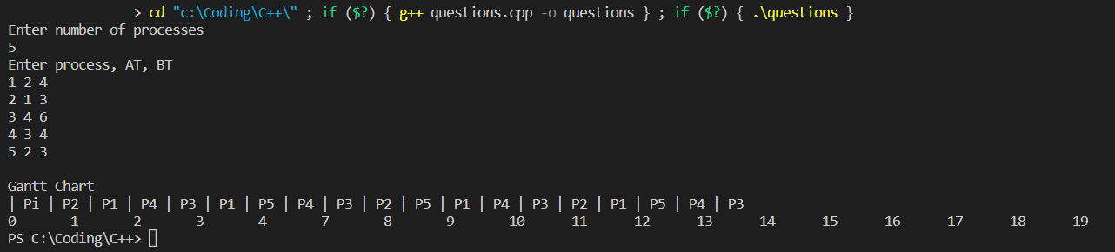

Experiment-8

Aim:
To implement the Banker’s algorithm

Introduction:
The banker’s algorithm is a resource allocation and deadlock avoidance algorithm that tests for safety by simulating the allocation for predetermined maximum possible amounts of all resources, then makes an “s-state” check to test for possible activities, before deciding whether allocation should be allowed to continue.

Algorithm:
1) Let Work and Finish be vectors of length ‘m’ and ‘n’ respectively. Initialize: Work = Available Finish[i] = false; for i=1, 2, 3, 4….n
2) Find an i such that both a) Finish[i] = false b) Needi <= Work if no such i exists goto step (4)
3) Work = Work + Allocation[i] Finish[i] = true goto step (2)
4) if Finish [i] = true for all i then the system is in a safe state

Code:

#include <iostream>
using namespace std;
int main()
{
int n, m, i, j, k;
n = 5;
m = 3;
int alloc[5][3] = {{0, 1, 0}, // P0 // Allocation Matrix
{2, 0, 0}, // P1
{3, 0, 2}, // P2
{2, 1, 1}, // P3
{0, 0, 2}}; // P4
int max[5][3] = {{7, 5, 3}, // P0 // MAX Matrix
{3, 2, 2}, // P1
{9, 0, 2}, // P2
{2, 2, 2}, // P3
{4, 3, 3}}; // P4

int avail[3] = {3, 3, 2}; // Available Resources
int f[n], ans[n], ind = 0;
for (k = 0; k < n; k++)
{
f[k] = 0;
}
int need[n][m];
for (i = 0; i < n; i++)
{
for (j = 0; j < m; j++)
need[i][j] = max[i][j] - alloc[i][j];
}
int y = 0;
for (k = 0; k < 5; k++)
{
for (i = 0; i < n; i++)
{
if (f[i] == 0)
{
int flag = 0;
for (j = 0; j < m; j++)
{
if (need[i][j] > avail[j])
{
flag = 1;
break;
}
}
if (flag == 0)
{
ans[ind++] = i;
for (y = 0; y < m; y++)
avail[y] += alloc[i][y];
f[i] = 1;
}
}
}
}
int flag = 1;
for (int i = 0; i < n; i++)
{
if (f[i] == 0)
{
flag = 0;
cout << "The given sequence is not safe";
break;
}
}
if (flag == 1)
{
cout << "Following is the SAFE Sequence" << endl;
for (i = 0; i < n - 1; i++)
cout << " P" << ans[i] << " ->";
cout << " P" << ans[n - 1] << endl;
}
}

Output:

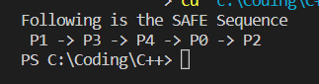

Experiment 9
Aim:
To implement the Producer-Consumer Problem using Semaphores

Introduction:
The producer-consumer problem is an example of a multi-process synchronization problem. The problem describes two processes, the producer and the consumer that shares a common fixed-size buffer use it as a queue.
• The producer’s job is to generate data, put it into the buffer, and start again.
• At the same time, the consumer is consuming the data (i.e., removing it from the buffer), one piece at a time.

Problem:
Given the common fixed-size buffer, the task is to make sure that the producer can’t add data into the buffer when it is full and the consumer can’t remove data from an empty buffer.

Solution:
The producer is to either go to sleep or discard data if the buffer is full. The next time the consumer removes an item from the buffer, it notifies the producer, who starts to fill the buffer again. In the same manner, the consumer can go to sleep if it finds the buffer to be empty. The next time the producer puts data into the buffer, it wakes up the sleeping consumer.

Algorithm:
The Producer Solution
do {
wait(empty);
wait(mutex);
signal(mutex);
signal(full);
} while(TRUE)

The Consumer Solution
The pseudocode for the producer function will look like this:
do {
wait(full);
wait(mutex);
signal(mutex);
signal(empty);
} while(TRUE);
Code:

#include <stdio.h>
#include <pthread.h>
#include <unistd.h>
#include <semaphore.h> /* sem_t */
#include <stdlib.h>
#define BUF_SIZE 2
struct buffer
{
int data;
};
struct buffer buf[BUF_SIZE];
sem_t fill, empty;
int value, i;
void *producer(void *data);
void *consumer(void *data);
int main(void)
{
int sel, prod_data, cons_data;
int k;
if (sem_init(&empty, 0, BUF_SIZE))
{
printf("Error: semaphore not initialize\n");
return -1;
}
if (sem_init(&fill, 0, 0))
{
printf("Error: semaphore not initialize\n");
return -1;
}
while (1)
{
printf(".........................................................\n");
printf("Selection\n");
printf("Producer : 1 | Consumer : 2 | Display : 3 | Exit : 0 || ");
scanf("%d", &sel);
printf(".........................................................\n");
switch (sel)
{
case 1:
sem_getvalue(&empty, &value);
// printf("Prod_e: %d\n", value);
sem_getvalue(&fill, &value);
// printf("Prod_f: %d\n", value);
printf("\nProducer\n");
pthread_t prod_t;
printf("Enter data:");
scanf("%d", &prod_data);
if (pthread_create(&prod_t, NULL, producer, (void *)&prod_data))
{
printf("Error: thread not created\n");
return -1;
}
break;
case 2:
printf("\nConsumer\n");
sem_getvalue(&empty, &value);
// printf("Cons_e: %d\n", value);
sem_getvalue(&fill, &value);
// printf("Cons_f: %d\n", value);
pthread_t con_t;
if (pthread_create(&con_t, NULL, consumer, (void *)&cons_data))
{
printf("Error: thread not created\n");
return -1;
}
if (i == 0)
{
printf("Buffer empty\n");
break;
}
case 3:
if (i == 0)
{
printf("Buffer empty\n");
break;
}
for (k = 0; k < i; k++)
printf("buf[%d]: %d\n", k, buf[k].data);
break;
case 0:
sem_destroy(&fill);
sem_destroy(&empty);
exit(0);
break;
}
}
sem_destroy(&fill);
sem_destroy(&empty);
return 0;
}
void *producer(void *arg)
{
int data = *(int *)arg;
if (sem_wait(&empty))
{ /* wait */
printf("Error: sem wait fail\n");
pthread_exit(NULL);
}
buf[i].data = data;
i++;
if (sem_post(&fill))
{ /* post */
printf("Error: sem wait fail\n");
pthread_exit(NULL);
}
pthread_exit(NULL);
}
void *consumer(void *arg)
{
if (sem_wait(&fill))
{ /* wait */
printf("Error: sem wait fail\n");
pthread_exit(NULL);
}
i--;
*(int *)arg = buf[i].data;
if (sem_post(&empty))
{ /* post */
printf("Error: sem wait fail\n");
pthread_exit(NULL);
}
pthread_exit(NULL);
}

Output:

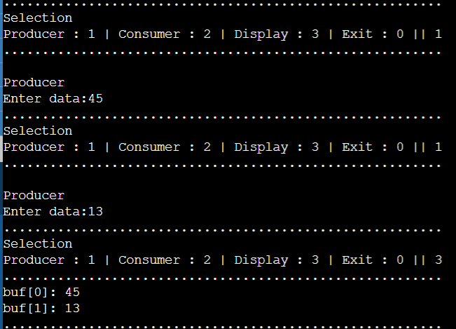

Experiment - 10

Aim:
Write a program to implement First In First Out (FIFO) page replacement algorithm

Theory:
A page replacement algorithm is required in an operating system that uses paging to manage memory in order to determine which page needs to be replaced when a new page is received. A page fault occurs when an active application tries to access a memory page that is loaded in virtual memory but not physically in the system. Page errors occur because actual physical memory is substantially less than virtual memory. In the event of a page fault, the operating system might have to swap out one of the current pages for the one that is now required. Different page replacement algorithms offer various suggestions for selecting the appropriate replacement page. All algorithms strive to lower the number of page faults. The simplest algorithm for replacing pages is this one. The operating system maintains a queue for all of the memory pages in this method, with the oldest page at the front of the queue. The first page in the queue is chosen for removal when a page has to be replaced.

Algorithm:
1. Begin turning the pages.
i) If the set can hold no more pages.
a) Add pages one at a time into the collection until it is full or all requests for pages have been fulfilled.
b) Maintain the pages in the queue simultaneously to carry out FIFO.
c) Increased page error
ii) Other
Do nothing if the current page is included in the collection. If not, either
a) the current page in the string should be substituted for the first page in the queue since it was the first to be placed into memory, or
b) the first page in the queue should be removed.
c) Add the currently viewing page to the queue.
d) Page faults that increase.
2. Return page errors

Code:

#include <stdio.h>
int main()
{
int incomingStream[] = {4, 1, 2, 4, 5};
int pageFaults = 0;
int frames = 3;
int m, n, s, pages;
pages = sizeof(incomingStream) / sizeof(incomingStream[0]);
printf(" Incoming \t Frame 1 \t Frame 2 \t Frame 3 ");
int temp[frames];
for (m = 0; m < frames; m++)
{
temp[m] = -1;
}
for (m = 0; m < pages; m++)
{
s = 0;
for (n = 0; n < frames; n++)
{
if (incomingStream[m] == temp[n])
{
s++;
pageFaults--;
}
}
pageFaults++;
if ((pageFaults <= frames) && (s == 0))
{
temp[m] = incomingStream[m];
}
else if (s == 0)
{
temp[(pageFaults - 1) % frames] = incomingStream[m];
}
printf("\n");
printf("%d\t\t\t", incomingStream[m]);
for (n = 0; n < frames; n++)
{
if (temp[n] != -1)
printf(" %d\t\t\t", temp[n]);
else
printf(" - \t\t\t");
}
}
printf("\nTotal Page Faults:\t%d\n", pageFaults);
return 0;
}

Output:

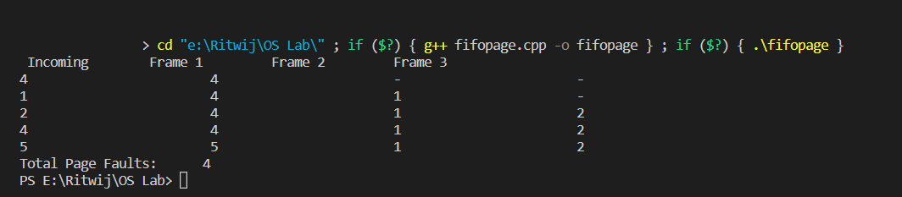

Experiment-11

Aim:
Write a program to implement Least Recently Used (LRU) page replacement algorithm.

Theory:
In operating systems that use paging for memory management, page replacement algorithm are needed to decide which page needed to be replaced when new page comes in. Whenever a new page is referred and not present in memory, page fault occurs and Operating System replaces one of the existing pages with newly needed page. Different page replacement algorithms suggest different ways to decide which page to replace. The target for all algorithms is to reduce number of page faults. In Least Recently Used (LRU) algorithm is a Greedy algorithm where the page to be replaced is least recently used. The idea is based on locality of reference, the least recently used page is not likely Let say the page reference string 7 0 1 2 0 3 0 4 2 3 0 3 2. Initially we have 4 page slots empty.

Code:

#include <iostream>
#include <unordered_map>
#include <unordered_set>
using namespace std;
int pageFaults(int pages[], int n, int capacity)
{
unordered_set<int> s;
unordered_map<int, int> indexes;
int page_faults = 0;
for (int i = 0; i < n; i++)
{
if (s.size() < capacity)
{
if (s.find(pages[i]) == s.end())
{
s.insert(pages[i]);
page_faults++;
}
indexes[pages[i]] = i;
}
else
{
if (s.find(pages[i]) == s.end())
{
int lru = INT32_MAX, val;
for (auto it = s.begin(); it != s.end(); it++)
{
if (indexes[*it] < lru)
{
lru = indexes[*it];
val = *it;
}
}
s.erase(val);
s.insert(pages[i]);
page_faults++;
}
indexes[pages[i]] = i;
}
}
return page_faults;
}
int main()
{
int pages[] = {7, 0, 1, 2, 0, 3, 0, 4, 2, 3, 0, 3, 2};
int n = sizeof(pages) / sizeof(pages[0]);
int capacity = 4;
cout << pageFaults(pages, n, capacity);
return 0;
}

Output:

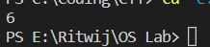

Experiment-12

Aim:
To implement the Dining Philosophers Problem using Semaphores

Introduction:
The dining philosopher's problem is the classical problem of synchronization which says that Five philosophers are sitting around a circular table and their job is to think and eat alternatively. A bowl of noodles is placed at the center of the table along with five chopsticks for each of the philosophers. To eat a philosopher needs both their right and a left chopstick. A philosopher can only eat if both immediate left and right chopsticks of the philosopher is available. In case if both immediate left and right chopsticks of the philosopher are not available then the philosopher puts down their (either left or right) chopstick and starts thinking again. The dining philosopher demonstrates a large class of concurrency control problems hence it's a classic synchronization problem.

Algorithm:
void Philosopher {
while(1) {
wait(use_resource[x]);
wait(use_resource[(x + 1) % 5]);
signal(free_resource[x]);
signal(free_resource[(x + 1) % 5]);
}
}

Code:

#include <bits/stdc++.h>
#include <pthread.h>
#include <unistd.h>
using namespace std;

#define N 10
#define THINKING 2
#define HUNGRY 1
#define EATING 0
#define LEFT (phnum + 4) % N
#define RIGHT (phnum + 1) % N

// Philosopher index
int phil[N];
int times = 200;

class monitor {

// state of the philosopher
int state[N];

// Philosopher condition variable
pthread_cond_t phcond[N];

// mutex variable for synchronization
pthread_mutex_t condLock;

public:
// Test for the desired condition
// i.e. Left and Right philosopher are not reading
void test(int phnum)
{

if (state[(phnum + 1) % 5] != EATING
and state[(phnum + 4) % 5] != EATING
and state[phnum] == HUNGRY) {
state[phnum] = EATING;

pthread_cond_signal(&phcond[phnum]);
}
}

// Take Fork function
void take_fork(int phnum)
{

pthread_mutex_lock(&condLock);

// Indicates it is hungry
state[phnum] = HUNGRY;

// test for condition
test(phnum);

// If unable to eat.. wait for the signal
if (state[phnum] != EATING) {
pthread_cond_wait(&phcond[phnum], &condLock);
}
cout << "Philosopher " << phnum << " is Eating"
<< endl;

pthread_mutex_unlock(&condLock);
}

// Put Fork function
void put_fork(int phnum)
{

pthread_mutex_lock(&condLock);

// Indicates that I am thinking
state[phnum] = THINKING;

test(RIGHT);
test(LEFT);

pthread_mutex_unlock(&condLock);
}

// constructor
monitor()
{

for (int i = 0; i < N; i++) {
state[i] = THINKING;
}

for (int i = 0; i < N; i++) {
pthread_cond_init(&phcond[i], NULL);
}

pthread_mutex_init(&condLock, NULL);
}

// destructor
~monitor()
{

for (int i = 0; i < N; i++) {
pthread_cond_destroy(&phcond[i]);
}

pthread_mutex_destroy(&condLock);
}
}

// Global Object of the monitor
phil_object;

void* philosopher(void* arg)
{
int c = 0;
while (c < times) {
int i = *(int*)arg;
sleep(1);
phil_object.take_fork(i);
sleep(0.5);
phil_object.put_fork(i);
c++;
}
}

int main()
{

// Declaration...
pthread_t thread_id[N];
pthread_attr_t attr;

// Initialization...
pthread_attr_init(&attr);
pthread_attr_setdetachstate(&attr,
PTHREAD_CREATE_JOINABLE);

for (int i = 0; i < N; i++) {
phil[i] = i;
}

// Creating...
for (int i = 0; i < N; i++) {
pthread_create(&thread_id[i], &attr, philosopher,
&phil[i]);
cout << "Philosopher " << i + 1 << " is thinking..."
<< endl;
}

// Joining....
for (int i = 0; i < N; i++) {
pthread_join(thread_id[i], NULL);
}

// Destroying
pthread_attr_destroy(&attr);
pthread_exit(NULL);

return 0;
}
Output:

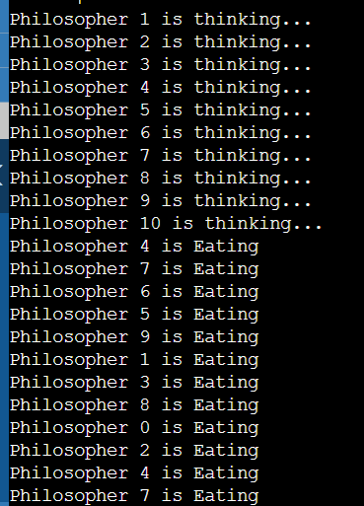
EXPERIMENT-13

Aim:
Write a program to implement Reader Writer Problem.

Introduction:
• There is a shared resource which should be accessed by multiple processes.
• There are two types of processes in this context.
• They are reader and writer.
• Any number of readers can read from the shared resource simultaneously, but only one writer can write to the shared resource.
• When a writer is writing data to the resource, no other process can access the resource.
• A writer cannot write to the resource if there are non-zero number of readers accessing the resource at that time.

Algorithm:
Here, readers have higher priority than writer. If a writer wants to write to the resource, it must wait until there are no readers currently accessing that resource. For that we use: -
• one mutex m and a semaphore w.
• An integer variable read_count :- to maintain the number of readers currently accessing the resource.
• The variable read_count is initialized to 0.
• A value of 1 is given initially to m and w. Instead of having the process to acquire lock on the shared resource, we use the mutex m to make the process to acquire and release lock whenever it is updating the read_count variable.
• a. Writer Process:
1. Writer requests the entry to critical section.
2. If allowed i.e. wait() gives a true value, it enters and performs the write. If not allowed, it keeps on waiting.
3. It exits the critical section.
b. Reader Process:
4. Reader requests the entry to critical section.
5. If allowed:
i. it increments the count of number of readers inside the critical section. If this reader is the first reader entering, it locks the w semaphore to restrict the entry of writers if any reader is inside.
ii.It then, signals mutex as any other reader is allowed to enter while others are already reading.
iii. After performing reading, it exits the critical section. When exiting, it checks if no more reader is inside, it signals the semaphore w as now, writer can enter the critical section.
- If not allowed, it keeps on waiting.

Code:

#include <semaphore.h>
#include <stdio.h>
#include <stdlib.h>
#include <unistd.h>
#include <pthread.h>
sem_t x, y;
pthread_t tid;
pthread_t writerthreads[100], readerthreads[100];
int readercount = 0;
void *reader(void *param)
{
sem_wait(&x);
readercount++;
if (readercount == 1)
sem_wait(&y);
sem_post(&x);
printf("%d reader is inside\n", readercount);
usleep(3);
sem_wait(&x);
readercount--;
if (readercount == 0)
{
sem_post(&y);
}
sem_post(&x);
printf("%d Reader is leaving\n", readercount + 1);
return NULL;
}
void *writer(void *param)
{
printf("Writer is trying to enter\n");
sem_wait(&y);
printf("Writer has entered\n");
sem_post(&y);
printf("Writer is leaving\n");
return NULL;
}
int main()
{
int n2, i;
printf("Enter the number of readers:");
scanf("%d", &n2);
printf("\n");
int n1[n2];
sem_init(&x, 0, 1);
sem_init(&y, 0, 1);
for (i = 0; i < n2; i++)
{
pthread_create(&writerthreads[i], NULL, reader, NULL);
pthread_create(&readerthreads[i], NULL, writer, NULL);
}
for (i = 0; i < n2; i++)
{
pthread_join(writerthreads[i], NULL);
pthread_join(readerthreads[i], NULL);
}
}

Output:

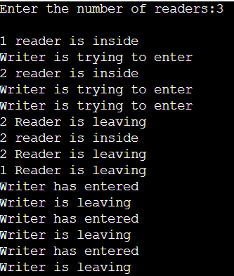
EXPERIMENT-14

Aim:
Write a program to implement the FCFS(First Come First Serve)
Disk Scheduling Algorithms.

Introduction:
FCFS is the simplest disk scheduling algorithm. As the name suggests, this algorithm entertains requests in the order they arrive in the disk queue. The algorithm looks very fair and there is no starvation (all requests are serviced sequentially) but generally, it does not
provide the fastest service.

Algorithm:
1. Let Request array represents an array storing indexes of tracks that have been
requested in ascending order of their time of arrival. ‘head’ is the position of disk
head.
2. Let us one by one take the tracks in default order and calculate the absolute distance
of the track from the head.
3. Increment the total seek count with this distance.
4. Currently serviced track position now becomes the new head position.
5. Go to step 2 until all tracks in request array have not been serviced.

Code:

#include <iostream>
using namespace std;
#define size 8
void FCFS(int arr[], int head)
{
int seek_count = 0;
int distance, cur_track;
for (int i = 0; i < size; i++)
{
cur_track = arr[i];
distance = abs(cur_track - head);
seek_count += distance;
head = cur_track;
}
cout << "Total number of seek operations = " << seek_count << endl;
cout << "Seek Sequence is" << endl;
for (int i = 0; i < size; i++)
{
cout << arr[i] << endl;
}
}
int main()
{
int arr[size] = {176, 79, 34, 60, 92, 11, 41, 114};
int head = 50;
FCFS(arr, head);
return 0;
}

Output:

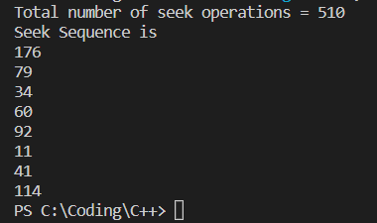

EXPERIMENT-15

Aim:
Write a program to implement the SSTF (Shortest Seek Time First)
Disk Scheduling Algorithms.

Introduction:
Given an array of disk track numbers and initial head position, our task is to find the total number of seek operations done to access all the requested tracks if Shortest Seek Time First (SSTF) is a disk scheduling algorithm is used.

Algorithm:
1. Let Request array represents an array storing indexes of tracks that
have been requested. ‘head’ is the position of disk head.
2. Find the positive distance of all tracks in the request array from head.
3. Find a track from requested array which has not been
accessed/serviced yet and has minimum distance from head.
4. Increment the total seek count with this distance.
5. Currently serviced track position now becomes the new head position.
6. Go to step 2 until all tracks in request array have not been serviced.

Code:

#include <iostream>
#define size 8
using namespace std;
void calculatedifference(int request[], int head, int diff[][2], int n)
{
for (int i = 0; i < n; i++)
{
diff[i][0] = abs(head - request[i]);
}
}
int findMIN(int diff[][2], int n)
{
int index = -1;
int minimum = 1e9;
for (int i = 0; i < n; i++)
{
if (!diff[i][1] && minimum > diff[i][0])
{
minimum = diff[i][0];
index = i;
}
}
return index;
}
void shortestSeekTimeFirst(int request[], int head, int n)
{
if (n == 0)
{
return;
}
int diff[size][2] = {{0, 0}};
int seekcount = 0;
int seeksequence[size + 1] = {0};
for (int i = 0; i < n; i++)
{
seeksequence[i] = head;
calculatedifference(request, head, diff, n);
int index = findMIN(diff, n);
diff[index][1] = 1;
seekcount += diff[index][0];
head = request[index];
}
seeksequence[n] = head;
cout << "Total number of seek operations = " << seekcount << endl;
cout << "Seek sequence is : "
<< "\n";
for (int i = 0; i <= n; i++)
{
cout << seeksequence[i] << "\n";
}
}
int main()
{

int proc[size] = {176, 79, 34, 60, 92, 11, 41, 114};
shortestSeekTimeFirst(proc, 50, size);
return 0;
}

Output:

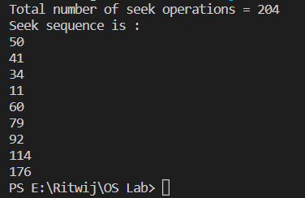

EXPERIMENT-16

Aim:
Write a program to implement the SCAN Disk Scheduling Algorithms.

Introduction:
Given an array of disk track numbers and initial head position, our task is to find the total number of seek operations done to access all the requested tracks if Shortest Seek Time First (SSTF) is a disk scheduling algorithm is used.

Algorithm:
1.Let Request array represents an array storing indexes of tracks that have been requested in ascending order of their time of arrival. ‘head ’is the position of disk head.
2.The head services only in the right direction from 0 to the size of the disk.
3.While moving in the left direction do not service any of the tracks.
4.When we reach the beginning (left end) reverse the direction.
5.While moving in the right direction it services all tracks one by one.
6.While moving in the right direction calculate the absolute distance of the track from the head.
7.Increment the total seek count with this distance.
8.Currently serviced track position now becomes the new head position.
9.Go to step 6 until we reach the right end of the disk.
10.If we reach the right end of the disk reverse the direction and go to step 3 until all tracks in the request array have not been serviced.

Code:

#include <bits/stdc++.h>
using namespace std;
int size = 8;
int disk_size = 200;
void CSCAN(int arr[], int head)
{
int seek_count = 0;
int distance, cur_track;
vector<int> left, right;
vector<int> seek_sequence;
left.push_back(0);
right.push_back(disk_size - 1);
for (int i = 0; i < size; i++)
{
if (arr[i] < head)
left.push_back(arr[i]);
if (arr[i] > head)
right.push_back(arr[i]);
}
sort(left.begin(), left.end());
sort(right.begin(), right.end());
for (int i = 0; i < right.size(); i++)
{
cur_track = right[i];
seek_sequence.push_back(cur_track);
distance = abs(cur_track - head);
seek_count += distance;
head = cur_track;
}
head = 0;
seek_count += (disk_size - 1);

for (int i = 0; i < left.size(); i++)
{
cur_track = left[i];
seek_sequence.push_back(cur_track);
distance = abs(cur_track - head);
seek_count += distance;
head = cur_track;
}
cout << "Total number of seek operations = " << seek_count << endl;
cout << "Seek Sequence is" << endl;
for (int i = 0; i < seek_sequence.size(); i++)
{
cout << seek_sequence[i] << endl;
}
}
int main()
{
int arr[8] = {176, 79, 34, 60, 92, 11, 41, 114};
int head = 50;
cout << "Initial position of head: " << head << endl;
CSCAN(arr, head);
return 0;
}

Output:

